Quick and simple start guide for using and exploring an L298N Dual H-Bridge Motor Controller module with a Tiva Controller.

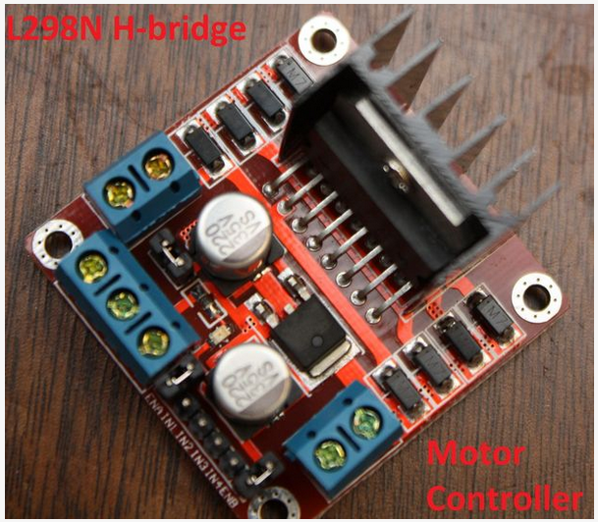

Step 1: Getting to know your L298N Dual H-Bridge Motor Controller module:
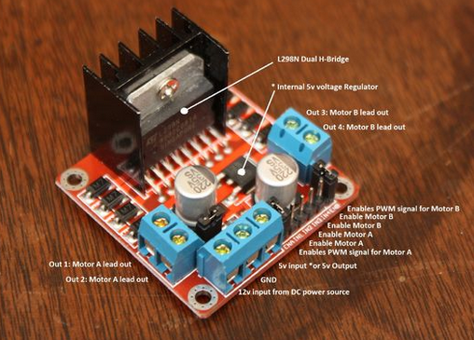

Usage:
H-Bridge's are typically used in controlling motors speed and direction, but can be used for other projects such as driving the brightness of certain lighting projects such as high powered LED arrays.
How it works:
An H-Bridge is a circuit that can drive a current in either polarity and be controlled by *Pulse Width Modulation (PWM).
* Pulse Width Modulation is a means in controlling the duration of an electronic pulse. In motors try to imagine the brush as a water wheel and electrons as a the flowing droplets of water. The voltage would be the water flowing over the wheel at a constant rate, the more water flowing the higher the voltage. Motors are rated at certain voltages and can be damaged if the voltage is applied to heavily or if it is dropped quickly to slow the motor down. Thus PWM. Take the water wheel analogy and think of the water hitting it in pulses but at a constant flow. The longer the pulses the faster the wheel will turn, the shorter the pulses, the slower the water wheel will turn. Motors will last much longer and be more reliable if controlled through PWM.
Pins:
- Out 1: Motor A lead out
- Out 2: Motor A lead out
- Out 3: Motor B lead out
- Out 4: Mo (Can actually be from 5v-35v, just marked as 12v)
- GND: Ground
- 5v: 5v Don't connect this, It's actually a 5VDC source if the board is supplied 7-35 volts.
- EnA: Enables PWM signal for Motor A
- In1: Enable Motor A
- In2: Enable Motor A
- In3: Enable Motor B
- In4: Enable Motor B
- EnB: Enables PWM signal for Motor B
Specifications:
- Double H bridge Drive Chip: L298N
- Logical voltage: 5V Drive voltage: 5V-35V
- Logical current: 0-36mA Drive current: 2A (MAX single bridge)
- Max power: 25W
- Dimensions: 43 x 43 x 26mm
- Weight: 26g

Using the motor driver to drive a single DC motor:
- Connect +12V and GND as shown above.
- Connect motor windings to Out1
- Connect GPIO to In1
- Connect GPIO to In2
- Be sure to tie a common ground between your Tiva board and the GND as well.
- In1 and In2 should be tied to two GPIO outputs on the tiva.
- The PWM Out should be connected to ENA.
- Direction is chosen by selecting In1 and In2 signals. These MUST be complements to drive the motor. There is a table in the datasheet to indicated how CW, CCW and Breaking work

